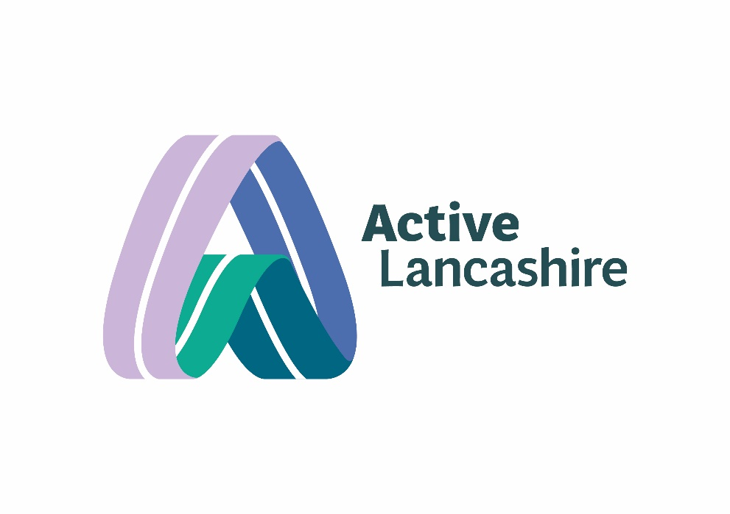 | Item:  4a | Report title:  Board of Directors/ Trustees Minutes and Actions
 | Date:  10.04.25 | Author:  Adrian Leather
Impact on Corporate Risk register? | Is this required? | Y
Environmental / Sustainability impact? | Is this required? | N
Welfare and safety of participants and beneficiary impact? | Is this required? | N

Executive Summary

Minutes and Actions from the Board meeting held on the 10th April 2025.

Action required by the Board

The Board to approve the minutes and note the updated actions.

ACTIVE LANCASHIRE LIMITED (“the Company”)
MINUTES OF A MEETING OF THE BOARD OF DIRECTORS / TRUSTEES
Held in person in the Conference Room, 1st Floor: Global Renewables – Enterprise Business Park, Sustainability Way, Leyland and via MS Teams video conference on Thursday, 10th April 2025 from 13:00 until 16:00hrs.
Present:
Brian Cookson OBE | Chair, Active Lancashire | BC
Dr Amanda Thornton | Director / Trustee | AT
Bryan Jones | Director / Trustee & Vice Chair, Active Lancashire | BJ
Danielle Roberts | Director/ Trustee | DR
Joanna Robinson | Director /Trustee | JR
Kathryn Moffitt | Director / Trustee | KMo
Roger Davies | Director /Trustee | RD
In attendance:
Adrian Leather | Chief Executive, Active Lancashire | AL
Darren Wright | Director of Community, Active Lancashire | DW
Laura Ivinson | Programme Lead, Move Together Blackpool | LI
Liz Mossop | Assistant Director / Head of Advice Services, Preston City Council | LM
Mark Stephenson | TaAF Toward an Active Future | MS
Stuart Oliver | Director of Finance | SO
Apologies:
CC Michael Green | Director / Trustee | MG
CC Rob Bailey | Director / Trustee | RB
CC Scott Smith | Director /Trustee | SS

1 | Chair Welcome and Quorum
1.1 | Adrian introduced the meeting and asked participants to introduce themselves and their organisations.
2 | Place Partnership Input
2.1  2.2  2.3  2.4  2.5  2.6 | Adrian and Brian discussed the role of place partnerships, their establishment, and the exciting developments happening within them. They emphasised the importance of collaboration and the need to support leaders and chief executives across Lancashire in their forward plans.  Adrian and Brian explained that place partnerships are collaborative efforts involving multiple organisations to improve physical activity and health outcomes in specific areas. They highlighted the importance of these partnerships in addressing local needs and leveraging resources effectively.  Adrian mentioned that some place partnerships have been established for a while, while others are still emerging. He noted that Blackpool is in its early stages but showing promising developments. The discussion included the need for clear communication and understanding of acronyms used within the partnerships.  Adrian emphasised the need for collaboration among partners and the importance of supporting leaders and chief executives across Lancashire. He suggested that a combined position could be developed to help leaders and chief executives consider how physical activity and active networks can support their forward plans.  Together Active Future Overview:  Adrian provided an overview of the Together Active Future programme, its origins, and its focus on changing decision-makers' mindsets to improve physical activity levels. He highlighted the diverse workstreams and the importance of collaboration with local networks.  Adrian explained that the Together Active Future programme is one of the original 12 place pilots for Sport England, established in 2018. It focuses on changing decision-makers' mindsets to improve physical activity levels in their communities.  Adrian highlighted that the programme includes various workstreams, such as active schools, active madrassahs, and leadership development. These workstreams aim to address different aspects of physical activity and health within the community.  Adrian stressed the importance of collaboration with local networks to ensure the success of the programme. He mentioned that the programme involves multiple organisations working together to achieve common goals.  Deepening Phase of Together Active Future:  Adrian explained the three core elements of the deepening phase: active environments, children and people, and primary care. He emphasised the need for collaboration and evaluation to ensure significant impacts and sustainability.  Adrian described the active environments element as focusing on improving places and spaces where people access physical activity. This includes active travel and making better use of existing spaces to encourage physical activity.  Adrian mentioned that the children and people element will build on the active schools and active madrassah workstreams. It aims to enhance physical activity opportunities within education settings, particularly in secondary schools and alternative provisions.  Adrian explained that the primary care element focuses on embedding physical activity within primary care networks. This includes working with GP practices to promote physical activity as part of their services.  Adrian emphasised the importance of collaboration amongst partners and the need for thorough evaluation to ensure the programmes significant impacts and sustainability. He mentioned that the programme will involve continuous learning and adaptation based on feedback and outcomes.  Blackpool's Move Together Programme:  Laura shared the progress of the Move Together Blackpool programme, including the systems leadership journey, development of principles and priorities, and the importance of meaningful conversations with residents and partner organisations.  Laura discussed the systems leadership journey, which began with a pilot programme in July 2023. This programme involved 26 local leaders and aimed to foster collaboration and leadership development across the system.  Laura highlighted the development of principles and priorities for the Move Together Blackpool programme. These include focusing on children and young people, housing and communities, long-term health conditions, skills, employment, education, and systems leadership.  Laura emphasised the importance of meaningful conversations with residents and partner organisations. She mentioned that these conversations help to understand local needs and build trusted relationships, which are crucial for the programme's success.  Preston's Health and Well-being Initiatives:  Liz provided an overview of Preston's health and well-being initiatives, including the development of a physical activity strategy, collaboration with local organisations, and the establishment of an anchor board to address strategic issues.  Liz explained that Preston is developing a physical activity strategy to address health and well-being issues in the community. This strategy aims to increase physical activity levels and improve overall health outcomes.  Liz highlighted the importance of collaboration with local organisations, such as Preston North End Community Trust and the voluntary sector. These collaborations help to deliver various health and well-being programs and initiatives.  Liz mentioned the establishment of an anchor board to address strategic issues related to health and well-being. This board includes representatives from various organisations and aims to provide strategic direction and support for health initiatives in Preston.  Devolution and Government Reorganisation:  The board discussed the potential impact of devolution and government reorganisation on their work, emphasising the importance of readiness and collaboration to take advantage of opportunities.  The board discussed how devolution and government reorganisation could impact their work. They emphasised the need to be ready to take advantage of new opportunities that may arise from these changes.  The board highlighted the importance of collaboration among partners to navigate the changes brought by devolution and government reorganisation. They stressed the need to work together to ensure that their initiatives continue to be effective and impactful.  The Board provisionally approved that Active Lancashire should progress opportunities for closer collaborative working with the three Place Partnerships to support Devolution/LGR and report back to the July Board. (Pending ratification)  The Board provisionally approved support for Preston’s Place Partnership submission. (Pending ratification)
3 | Apologies for absence
3.1 | Apologies were noted from Cllr Green, Cllr Bailey & Cllr Smith.  The Chair confirmed that the meeting was not quorate, and as such, any decisions would need to be taken for approval outside the meeting and recorded in the minutes. Items recorded below were provisionally approved by those in attendance and are subject to ratification by absent Board members. Once responses are received, the minutes will be updated accordingly, and these decisions will be formally confirmed.
3.2 | There were no Declarations of Interest noted.
4 | Minutes of the Previous Meetings
4.1 | The Board approved the minutes of the meetings held on 16 October 2024 and 29 January 2025, along with the minutes of the Audit & Finance Committee meeting on 24 March 2025 and the Nominations & Remuneration Committee meeting on 4 March 2025, as a complete and accurate record.  The Board provisionally approved the minutes from 16 October 2024 and 29 January 2025 as a true and accurate record. (Pending ratification)
4.2 | The actions were noted within the Action log.
4.3 | The Board noted that there were no matters arising.
5 | CEO Report – Questions from Board
5.1 | Adrian presented the Chief Executive's report, highlighting the need for a mid-term refresh of the 10-year strategy, the importance of addressing undercapacity issues, and the progress of various initiatives, including the place universal offer and MP engagement.  Adrian emphasised the need for a mid-term refresh of the 10-year strategy to ensure it remains relevant and effective. This refresh will involve reviewing and updating the strategy based on current needs and priorities.  Adrian highlighted the importance of addressing undercapacity issues within the organisation. He mentioned that some key areas might be overcommitted, and there is a need to ensure sufficient capacity to deliver on their initiatives effectively.  Adrian provided an update on the place universal offer, which aims to support local areas in improving physical activity and health outcomes. He mentioned that the organisation has received the green light for this initiative and is working on its implementation.  Adrian discussed the progress of MP engagement efforts, highlighting the importance of building relationships with local MPs to gain their support for the organisation's initiatives. He mentioned that these efforts are crucial for securing funding and support for their programmes.  The Board provisionally approved the CEO report.
6 | Integrated Performance Report (IPR) – Questions from Board
6.1 | Darren provided an update on the integrated performance report, covering various programs and initiatives, including the health training contract, family hubs, active cycles, and the outdoor partnership.  Darren mentioned that the health training contract is in place until the end of September. The contract will be re-tendered from October, and budget changes are expected.  Darren highlighted the success of the family hubs programme, particularly in Pendle, where multi-skills training has been provided to staff. This programme has been recognised as good practice and is being shared across other family hubs.  The Board provisionally approved the IPR report.
7 | Finance
7.1 | Stuart presented the finance update, discussing the budget, medium and long-term risks, and the importance of managing pension liabilities. He also highlighted the need for a three-way agreement between Active Lancashire, Lancashire County Council, and the LGPS.  The Board provisionally approved the finance update.  The Board provisionally approved submitting an application for the Sport England Universal Offer.  The Board provisionally approved continued collaboration on the Connect to Work offer, with a note of caution regarding complexity and accountability in any lead partner role.
7.2 | Business development plan
7.3 | The board agreed to establish a business development subcommittee to support the organisation's growth and development, with terms of reference to be drafted for the next board meeting.
8 | Pension Review
8.1 | Stuart provided an overview of the pension scheme review, discussing the potential options for managing pension liabilities, the importance of a three-way agreement, and the need for further discussions with Lancashire County Council and the LGPS.  The Board provisionally approved the pension update briefing report.  The Board provisionally approved joint discussions with LGPS, Lancashire County Council, and Active Lancashire to explore pension scheme options.  Joanna Robinson volunteered to represent the Board in these discussions.  The Board provisionally approved that an employee under 55 should also be involved, and Sarah Bennett (Director of Business) will approach a suitable individual.  The Board provisionally approved further exploration of a defined contribution pension scheme for new starters.  The Board provisionally approved that a follow-up paper with progress and options be brought to the July Board.
9 | Business Recruitment progress
9.1 | Adrian updated the board on the ongoing recruitment process, noting the diverse range of candidates and the importance of finding commercially savvy individuals to join the board.  Adrian informed the board about a confidential issue reported to the PIPOT panel and the steps being taken to address it, including an internal investigation and reporting to the HR committee.  The Board noted positive progress in recruiting two new Board members.
10 | Safeguarding alert  The Board provisionally approved the update report and noted the potential need to report to the CQC and Charity Commission
11 | Board reflection / Any other business
The following were noted under any other business:
- Let Me Move project: Danielle mentioned the Let Me Move project, which aims to make outdoor spaces more accessible for disabled people and encouraged board members to share the opportunity with their networks.
- Board Pack: Adrian commented that the Board pack is in a strong place, noting that it is clear, well-structured, and easy to navigate. He expressed hope that this standard will be maintained going forward.
- Teams Restructuring: Adrian reported that the team is moving forward with more confidence and less anxiety as a result of the restructuring, and that there are opportunities coming through, indicating that momentum has not been lost.
  - Adrian reported that the team is now moving forward with more confidence and less anxiety due to the recent restructuring. This change has positively impacted the team's morale and outlook.
  - Adrian mentioned that new opportunities are emerging as a result of the restructuring. The team is sensing these opportunities and is motivated to pursue them.
  - Adrian assured that despite the changes, the team has not lost momentum. The restructuring has been beneficial, and the team is progressing well.

12 | Actions for the next meeting
12.1 | Pension Scheme Review: Investigate the best option for an alternative pension scheme and have a three-way conversation with LCC and LGPS. (Stuart)
12.2 | Pension Scheme Review: Seek support from Sport England for potential legal advice regarding the pension scheme issue. (Stuart)
12.3 | Pension Scheme Review: Join the conversation with LCC and LGPS to provide an independent perspective on the pension scheme issue. (Joanna)
12.4 | Board Recruitment: Continue the board recruitment process and ensure a diverse range of candidates are considered. (Adrian)
12.5 | Business Development Subcommittee: Draft terms of reference for the new Business Development Subcommittee for the board to consider. (Sarah)
12.6 | Business Development Update: Provide a fuller update on business development activities and bids at the next board meeting. (Sarah)
12.7 | Empire Fighting Chance: Arrange a board briefing about the Empire Fighting Chance programme for the next board meeting. (Adrian)
12.8 | Let Me Move Project: Send information about the Let Me Move project to Joanna for potential candidates. (Darren)
12.9 | Board Pack Distribution: Send the pack around to the team. Roger Davies highlighted this as a positive (Adrian)
12.10 | Card from the Board: Ensure that Claire received a card from the Board. (Adrian - completed)
13 | Date of next meeting
13.1 | The next Board meeting will take place on 31th July 2025, 13.00-16.00 at Global renewables, Leyland.

Signed by the Chair of the Board: |  | Date:

